Figure 3

Wellington Industries Die Centering Slot
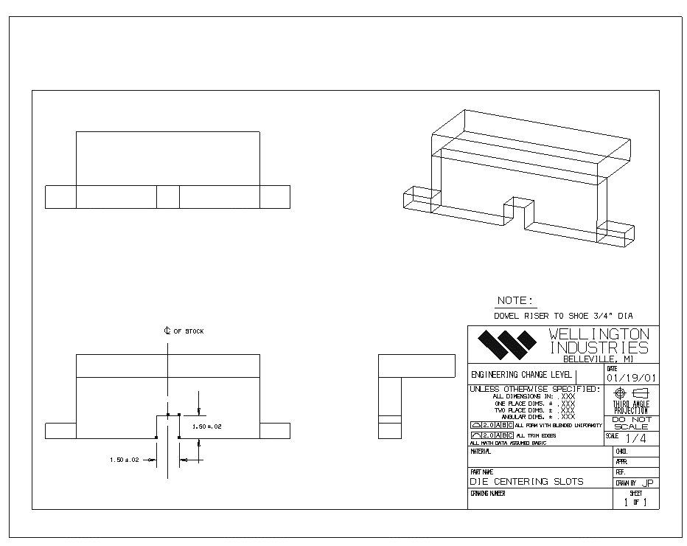

Figure 4

